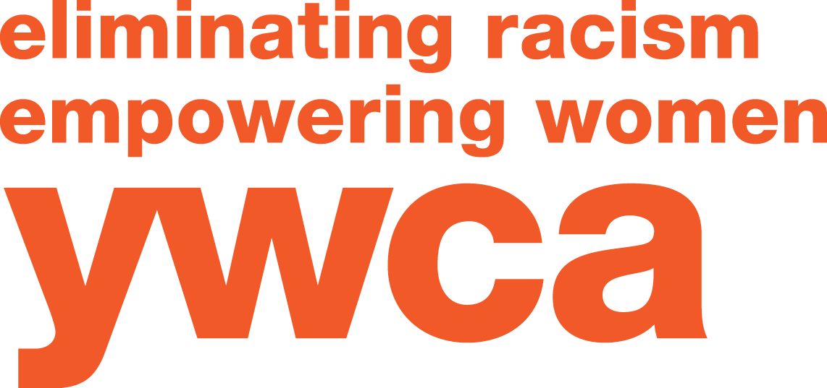
2017 YWCA Women of Achievement Women’s Empowerment Scholarship

YWCA Northwestern Illinois is pleased to offer a $1,500 educational scholarship to support the continuing education goals of women residing in the YWCA service areas of Boone, Winnebago, Stephenson, and Jo Daviess counties. This scholarship has been created to make post-secondary achievement more accessible to the non-traditional student, and support the advancement of women in Northern Illinois.
Eligible applicants will be:
- Woman, 23 years of age or older
- Residing in Boone, Winnebago, Stephenson, or Jo Daviess counties;
- Enrolled or accepted into an academic degree or professional certification program at an accredited post-secondary educational college, university, or vocational program.
Criteria for consideration:
- Financial need
- Community involvement
- Educational and career goals
- Previous work experience and/or internships
- Strengths and special abilities
To be eligible for review, applications must:
- Meet all format requirements listed within the application;
- Be typed/word-processed, complete, and signed where indicated;
- Include applicant name on each page;
- Include two letters of reference (original and signed)
Applicants may be asked to participate in a final in-person interview, date to be determined.
YWCA Women of Achievement Scholarship will be announced at Leader Luncheon XXXVII, Monday, March 6, 2017. Eligible applicants are asked to attend as a guest of YWCA Northwestern Illinois. RSVP to CydneyO@ywcanwil.org. Additional guests: $55 per ticket
Completed forms and essays must be postmarked no later than January 20, 2017. Mail to:
YWCA Northwestern Illinois
WOA Scholarship
4990 East State Street
Rockford, IL 61108

General Information
Applicant name
Applicant address
City/Zip Telephone
Email address
High school Graduation /GED date
School City/Zip Telephone
Current Post-Secondary School
Major or professional certification

Submission Checklist
- Postmarked or delivered by January 20, 2017
- 23 or older
- Completed application
- Financial needs (separate sheet)
- Essay (separate sheet)
- 2 letters of reference – original and signed

Applicant
Section 1. Community and professional activity: List community activities and work experience. Be detailed and specific about your role, achievements and time involved. Use additional copies of this sheet or add rows if necessary.
Company/organization | Your role  (what did you do?) | Leadership, achievements, recognitions | Date range and time commitment
Example:  ACME Non-Profit | Youth Group Mentor | Volunteer of the Year; Increase group participation year over year | 2012 to present, 1 hour/week

Community/Volunteerism
Company/organization | Your role | Leadership, achievements, recognitions | Date range and time commitment

Employment
Company/organization | Your role | Leadership, achievements, recognitions | Date range and time commitment

Internships or other activities
Company/organization | Your role | Leadership, achievements, recognitions | Date range and time commitment
Applicant
Section 2. Goals and interests: Please describe in detail, your goals, interests, and talents. (Limit 2 pages for section 2.)
a. Educational and career goals (short and long-term)

b. Special interests

c. Strengths and special abilities

Applicant
Section 3. Needs: Include a detailed breakdown of education costs, finance plans, and additional funding sources.
Section 4. Scholarship Essay: On a separate page, please type a 200-500-word, double-spaced composition on the following topic. Include your name at the top of each page.

Essay Topic
The mission of the YWCA is “Eliminating racism, empowering women, and promoting peace, justice, dignity for all.” What do you think are the most critical issues currently facing this mission? How will your plans for your future further the mission and values of the YWCA?

