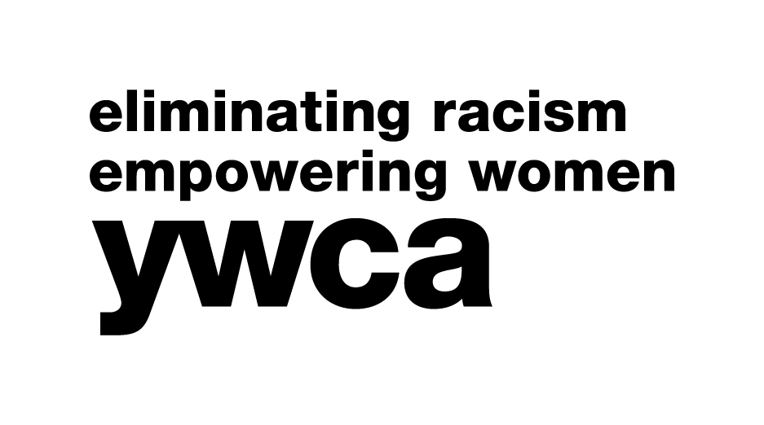
2023 Bright Future Scholarship

INFORMATION SHEET

YWCA Northwestern Illinois will present $1,500 Bright Future Scholarships to two female high school seniors residing in Boone, Winnebago, Stephenson or Jo Daviess Counties, and demonstrating the leadership characteristics and potential to affect positive change. Deadline: January 20, 2023

MINIMUM REQUIREMENTS

Only those applicants meeting the following requirements will be eligible for this scholarship:

- Applicant must be a female high school senior.
- Applicant must be planning to continue her education, not limited to college.
- Applicant must be a resident of and attending high school in Boone, Winnebago, Stephenson, or Jo Daviess Counties.
- Applicant must maintain a 2.5 scholastic average or equivalent.

CRITERIA FOR CONSIDERATION

The following items will be given careful consideration in evaluating applicants for this scholarship:

- Applicant should display leadership characteristics and the potential to affect change.
- Applicant should exhibit qualities including, but not limited to:
- courage and tenacity to overcome barriers and obstacles to achievement;
- creative thinking and problem solving;
- accepting and delegating responsibility;
- expressing concern and demonstrating tolerance;
- a commitment to diversity;
- strong written and verbal communication skills.

FORMAT REQUIREMENTS CHECKLIST

The following requirements must be met for application to be considered, all others will be rejected:

  - All information must be typed or word-processed on the enclosed forms or copies thereof, except for the required essay.
  - An essay must be submitted and must be typed or word-processed on a separate sheet, double-spaced, and included with the application.
  - The essay must be limited to one page, using a legible font no smaller than 10-point and double-spaced.
  - Applicant’s name must be filled in on each requested name field.
  - The application MUST be reviewed and signed by the counselor and the applicant.
  - The application should not be stapled, bound, or placed in a folder. Information not solicited (i.e., pictures, letters of recommendation, etc.) will not be considered and should not be included.

APPLICATION IN MICROSOFT WORD FORMAT

This application may be downloaded in PDF form for typing or Microsoft Word format (preferred method) by visiting the YWCA Northwestern Illinois website at https://www.ywcanwil.org/scholarships/.

Bright Future Scholarship Application Information Sheet, Continued – Page 2

Please note the following tips for working in the Microsoft Word format:

- Do not re-create the document.
- Sections are organized into tables. You may add rows as needed. This may add pages, which is acceptable. Be sure to add your name to additional pages (see last bullet point).
- If the text within a cell exceeds that cell, the document is set to expand that cell.
- Please be sure this has occurred when you print your application. Please do not alter the formatted page breaks.
- Please be certain to check for required name fields as the area normally at the top of the page where the field has been originally placed may shift as the document expands with text.

TIPS AND SUGGESTIONS

As you complete your application, please keep these things in mind:

  - Leadership and service are top considerations in this application.
  - Correct grammar, punctuation, and spelling throughout the application and essay are exceedingly important. Use your spell check and proof for errors.
  - The essay is weighted heavily for content as well as grammatical construction.
  - Details are necessary and helpful to those evaluating your application.
  - Instructions given on the application must be followed explicitly for application to be considered.
  - You are presenting yourself in the present as well as the future. In other words, this is who I am now and who I expect to become.

PERSONAL INTERVIEW

Applicants should be aware that a personal interview may be required as part of the selection process. If needed, you will be contacted at the phone number provided on your application.

SUBMITTING APPLICATIONS

Completed forms and essays must be delivered to the YWCA office or postmarked U.S. Mail no later than Friday, January 20, 2023. No exceptions. Mail to:

YWCA Northwestern Illinois
Bright Future Application
4990 E. State Street
Rockford, IL 61108

YWCA Northwestern Illinois
2022 Bright Future Scholarship Application

PLEASE REVIEW THE INFORMATION SHEET BEFORE PROCEEDING.

To be considered for this scholarship:
- All criteria and format requirements listed on the Information Sheet must be met;
- All sections of this application form must be typed or word-processed, completed, and signed by the applicant and school counselor/administrator, where indicated;
- Applicant’s name must appear on each page request;
- A personal interview may be required.

GENERAL INFORMATION

Applicant’s Name
Applicant’s Address
City/Zip |  | Telephone
Applicant’s Email Address
School & Address
City/Zip |  | Telephone
Parents/Guardian

Completed and signed forms and essays must be delivered to the YWCA office or postmarked
U.S. Mail no later than January 14, 2022. No exceptions.

Mail to:
YWCA Northwestern Illinois
Bright Future Application
4990 E. State Street
Rockford, IL 61108

How did you hear about this scholarship and where did you obtain the form? (check all that apply)
School counselor or administrator
Friend
Newspaper
YWCA Website
Other:

Applicant Name

Section 1. School Activities: List high school activities. Be detailed and specific about your role, achievements and time involved. Feel free to add more rows if necessary (or use an additional duplicate sheet if using a typewriter).

9 | 10 | 11 | 12 | Activity | Your Role (what did you do?) | Leadership, achieve-  ments, recognitions | Time involved
X | X | X | X | Example: Volleyball | EX: Captain 11 & 12 | EX: Most Valuable Player | EX: 6 hours/wk
ACADEMICS
ARTS
ATHLETICS
OTHER ACTIVITIES

Applicant Name

Section 2. Community Activities: List community activities and work experience. Be detailed and specific about your role, achievements, and time involved. Feel free to add more rows if necessary (or use an additional duplicate sheet if using a typewriter).

9 | 10 | 11 | 12 | Activity | Your Role (what did you do?) | Leadership, achieve-  ments, recognitions | Time involved
 |  | X | X | Example:  Hospital Volunteer | EX: Started new flower delivery system | EX: Volunteer of the year | EX: 1 hour/wk
COMMUNITY
SPIRITUAL COMMUNITY
PAID EMPLOYMENT
INTERNSHIPS
OTHER ACTIVITIES

Applicant Name

Section 3. Other Activities and Interests: To help the selection committee get to know the “Real You,” please describe in detail your goals, interests, and talents. Feel free to add more rows if necessary (or use an additional duplicate sheet if using a typewriter). Limit is 2 pages for section 3.

- Educational and Occupational Goals (short-term and long-term)

- Hobbies and Interests

- Strengths and Special Abilities

Applicant Name

Section 4. Scholarship Essay: On a separate sheet of paper, please type or word-process a double-spaced, one-page composition (using a legible font no smaller than 10-point) on the following topic.
Be sure your name appears on your essay.

What do you think is the most critical issue women will face in the next 20 years?
How do you see it being resolved?
Support your answer with verifiable information.

Section 5. Grade Point Average: Please provide the following information:

Applicant’s Grade Point Average |  | of |  | total points

For Example: 2.5 of 4.0 total points

Section 6. Counselor Verification: Application MUST be signed by a Counselor or School Administrator and the applicant to be considered for the Bright Future Scholarship.

I have reviewed and verified the enclosed information.

Counselor/School Administrator Signature (above) |  | Date
Print Name and Title
Bright Future Applicant Signature (above) |  | Date

